1. Program to print 4 integers a,b,c and d (Using if)

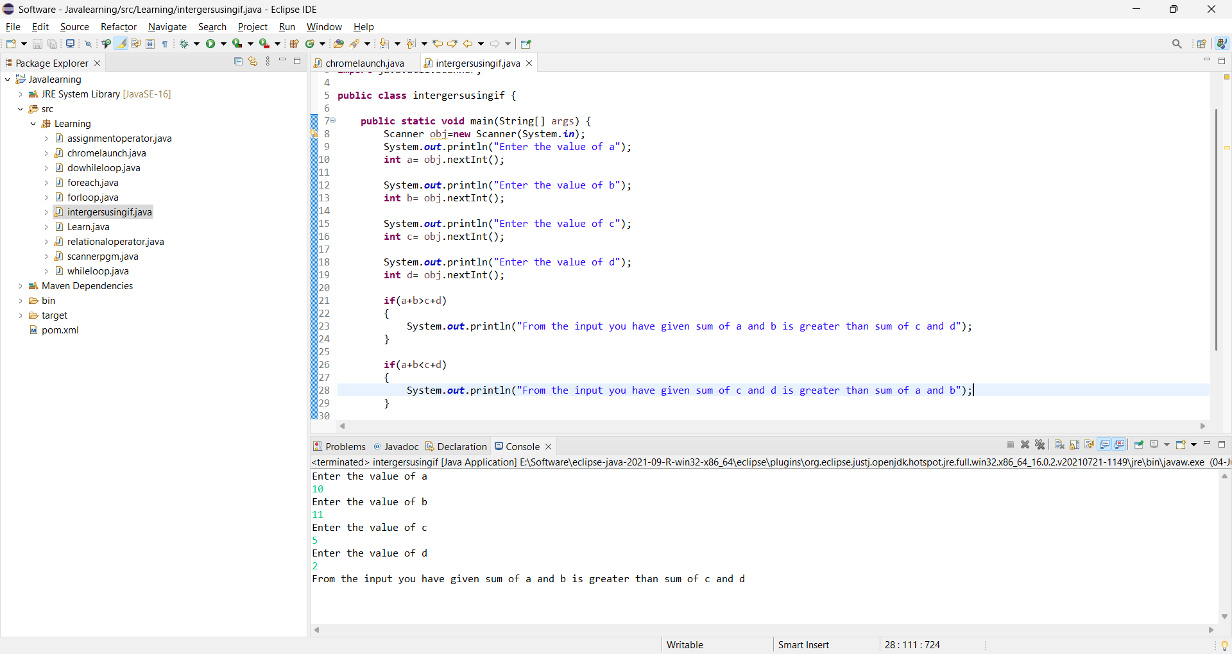

1. “IF ” program to identify whether the given int is even number

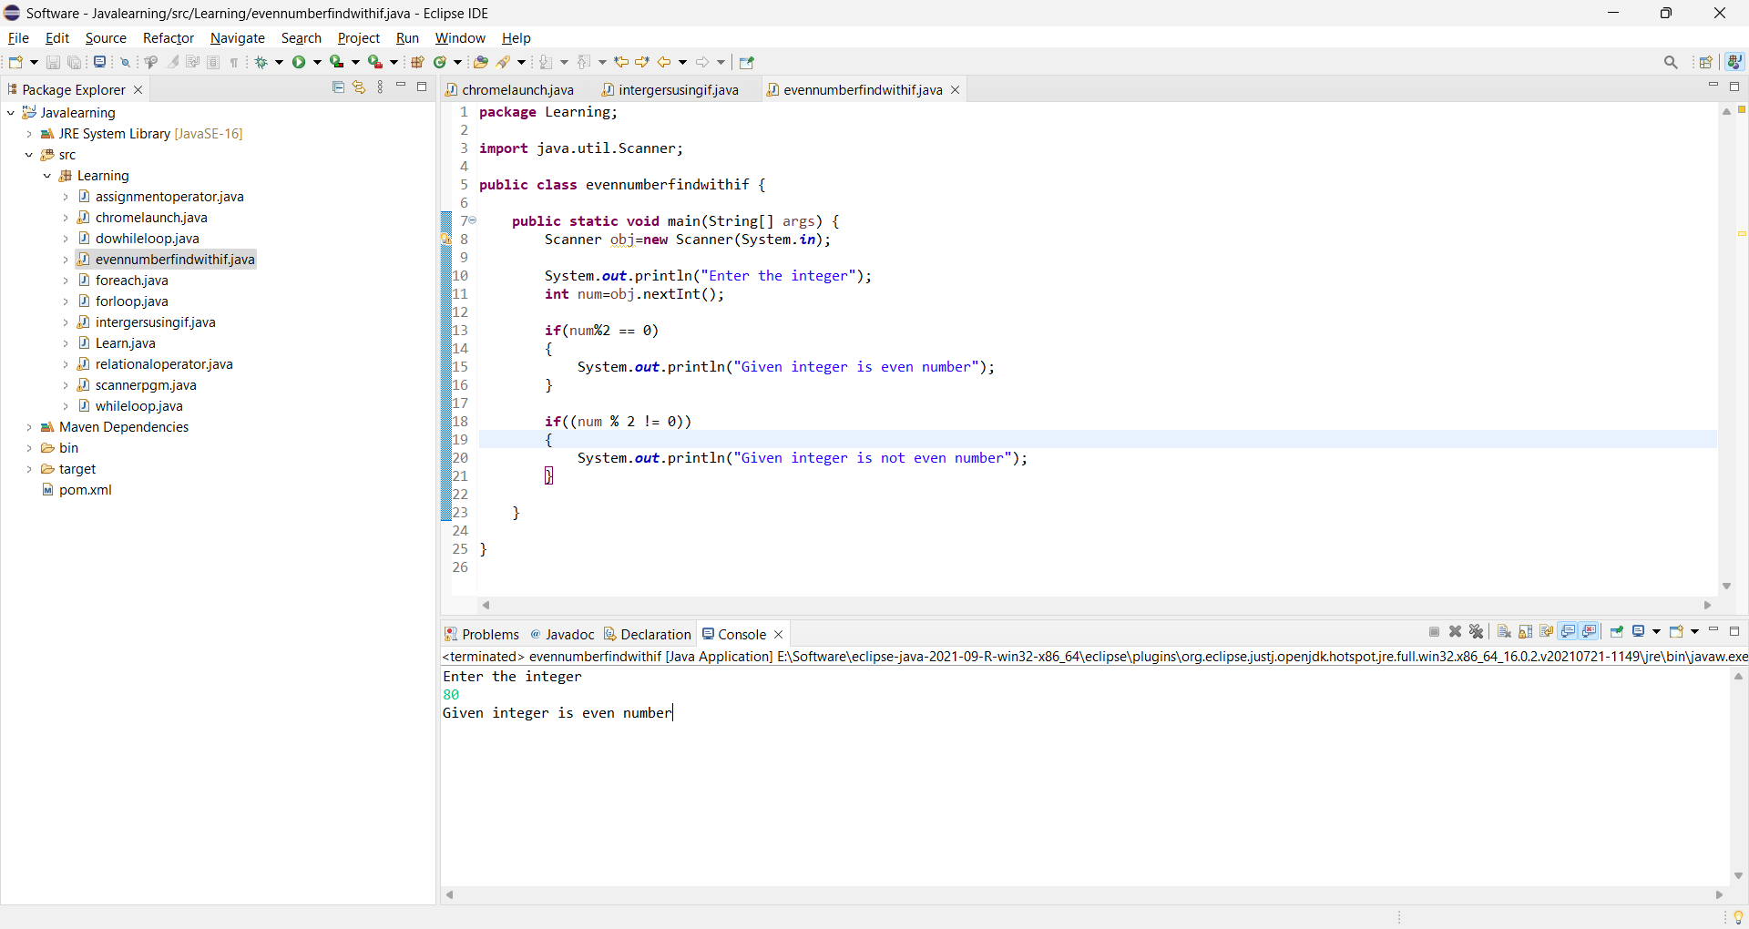

1. Java Program to print the characters from A to Z

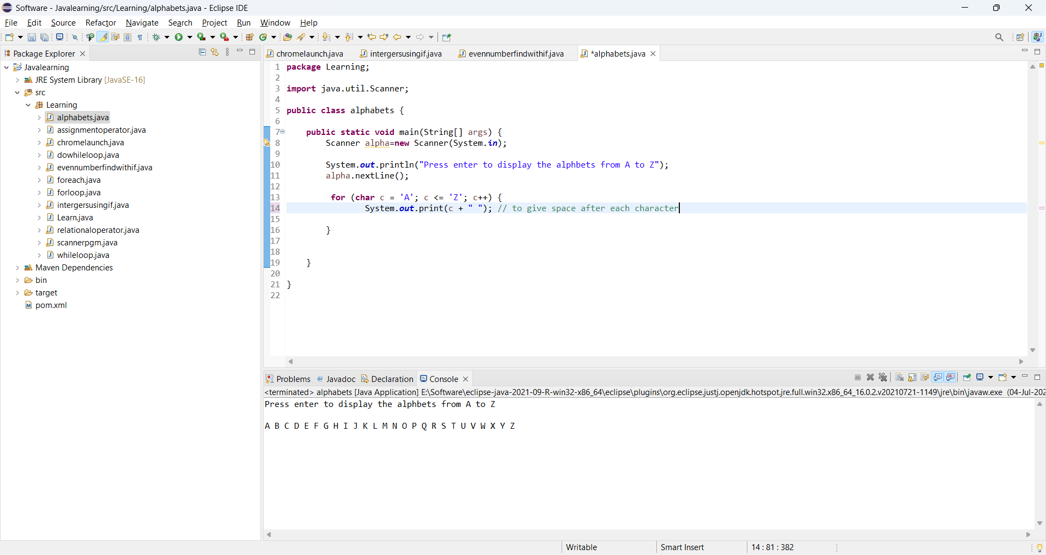

1. Numbers swapping

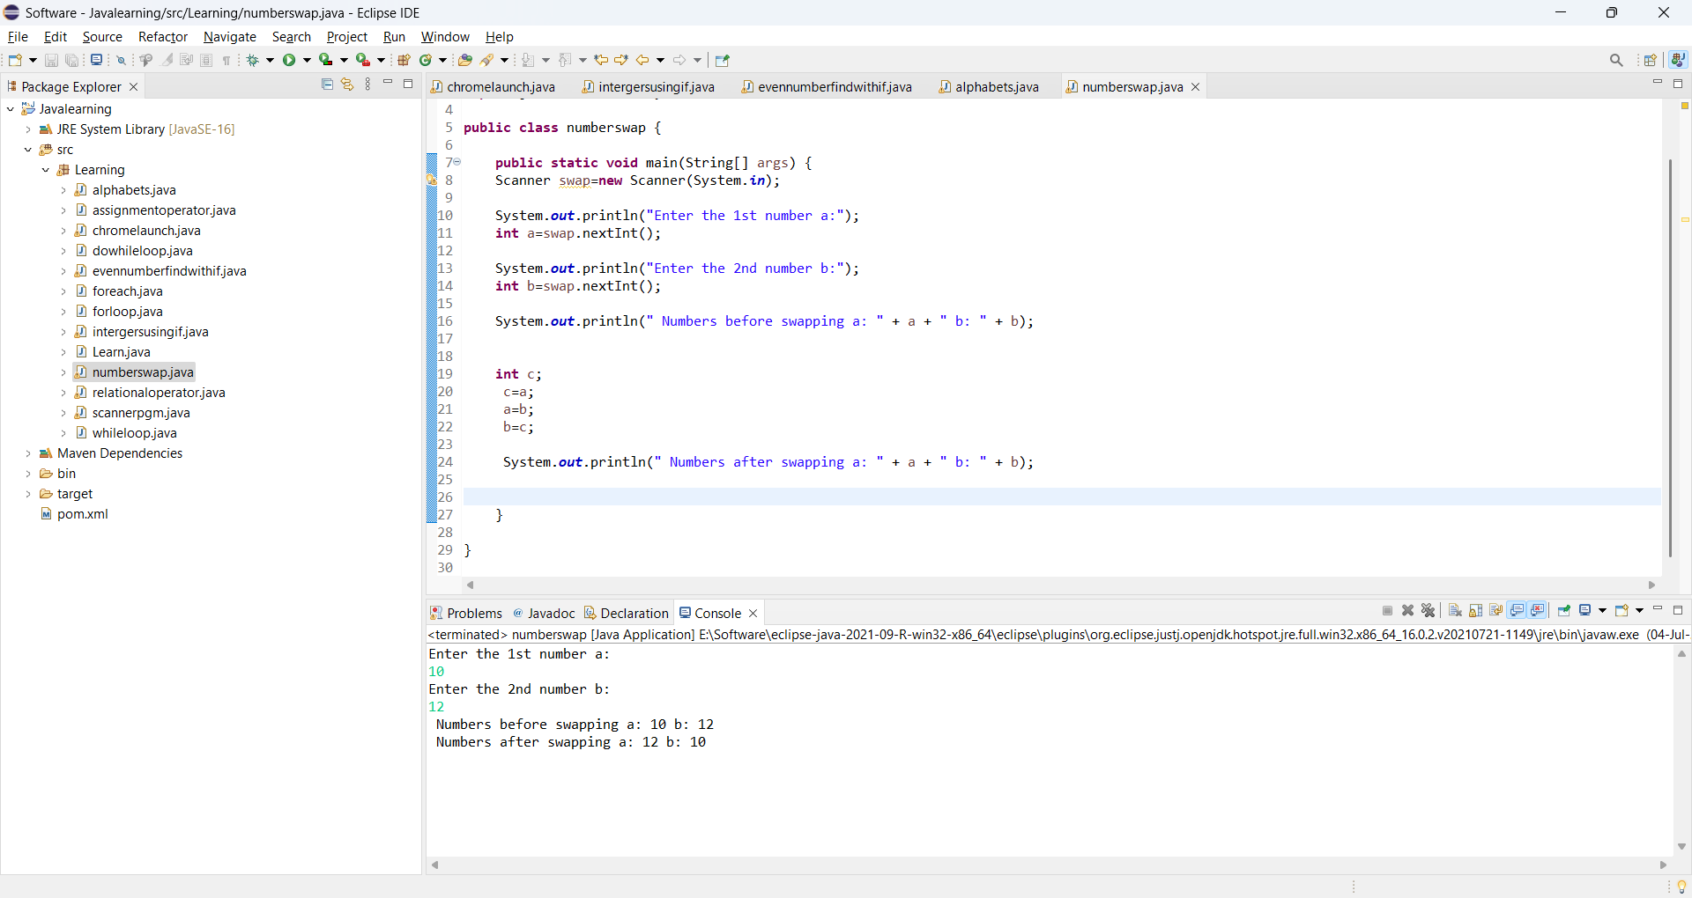

1. To check whether the number is prime or not

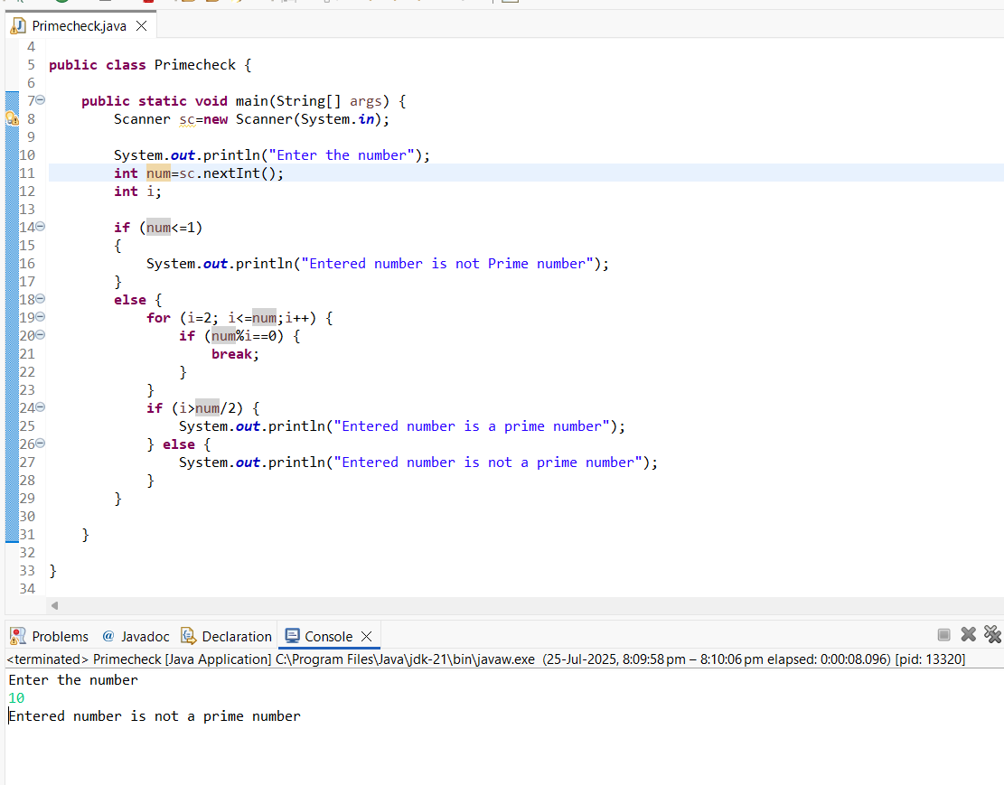

1. Program to print the factorial of the given number

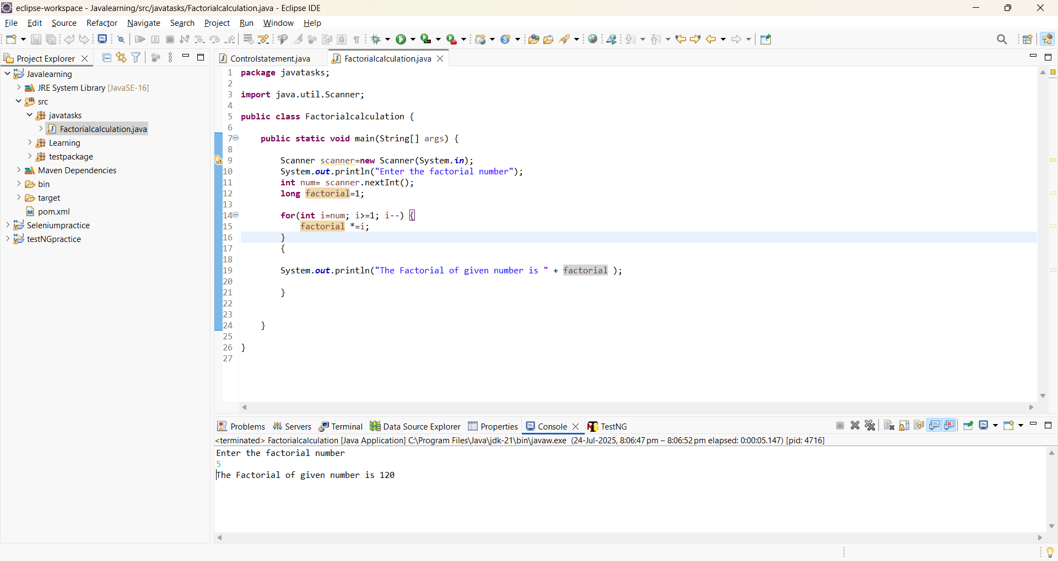

1. Program to print the length of string “Guvi Geek”

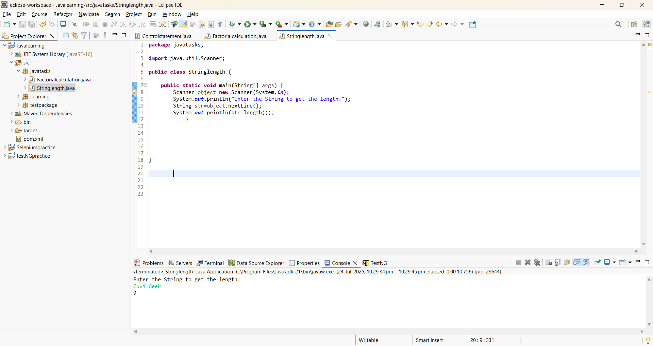

1. Program to print the given string 10 times

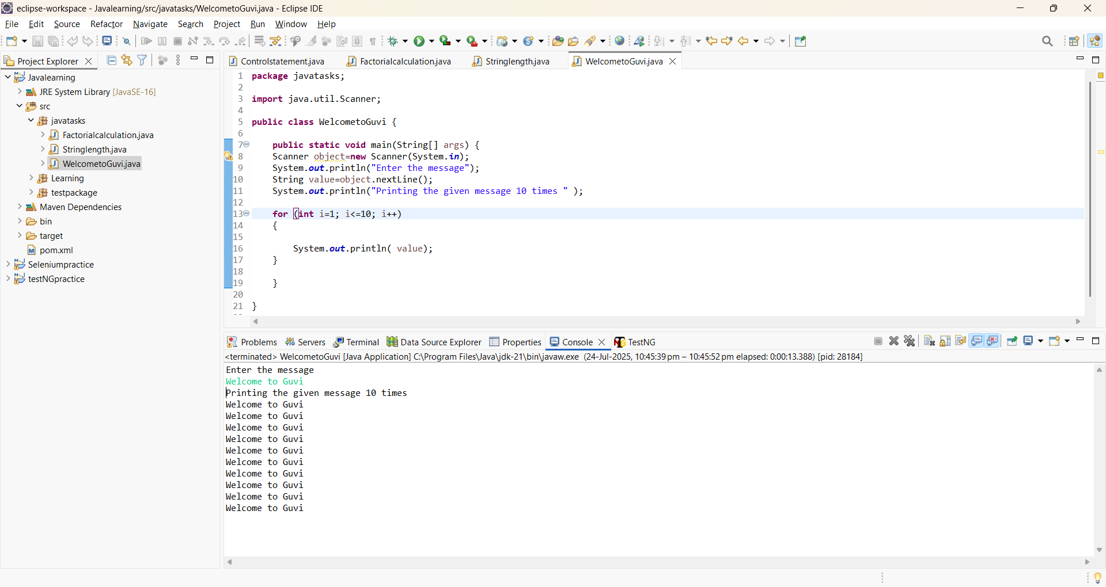

1. Program to find whether the person is Senior Citizen

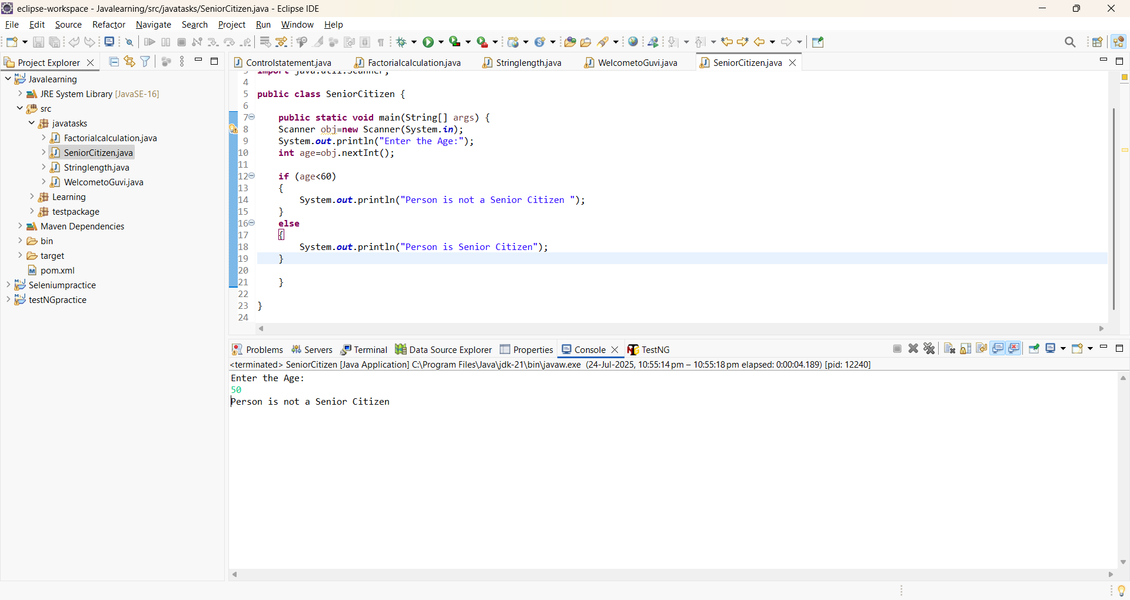

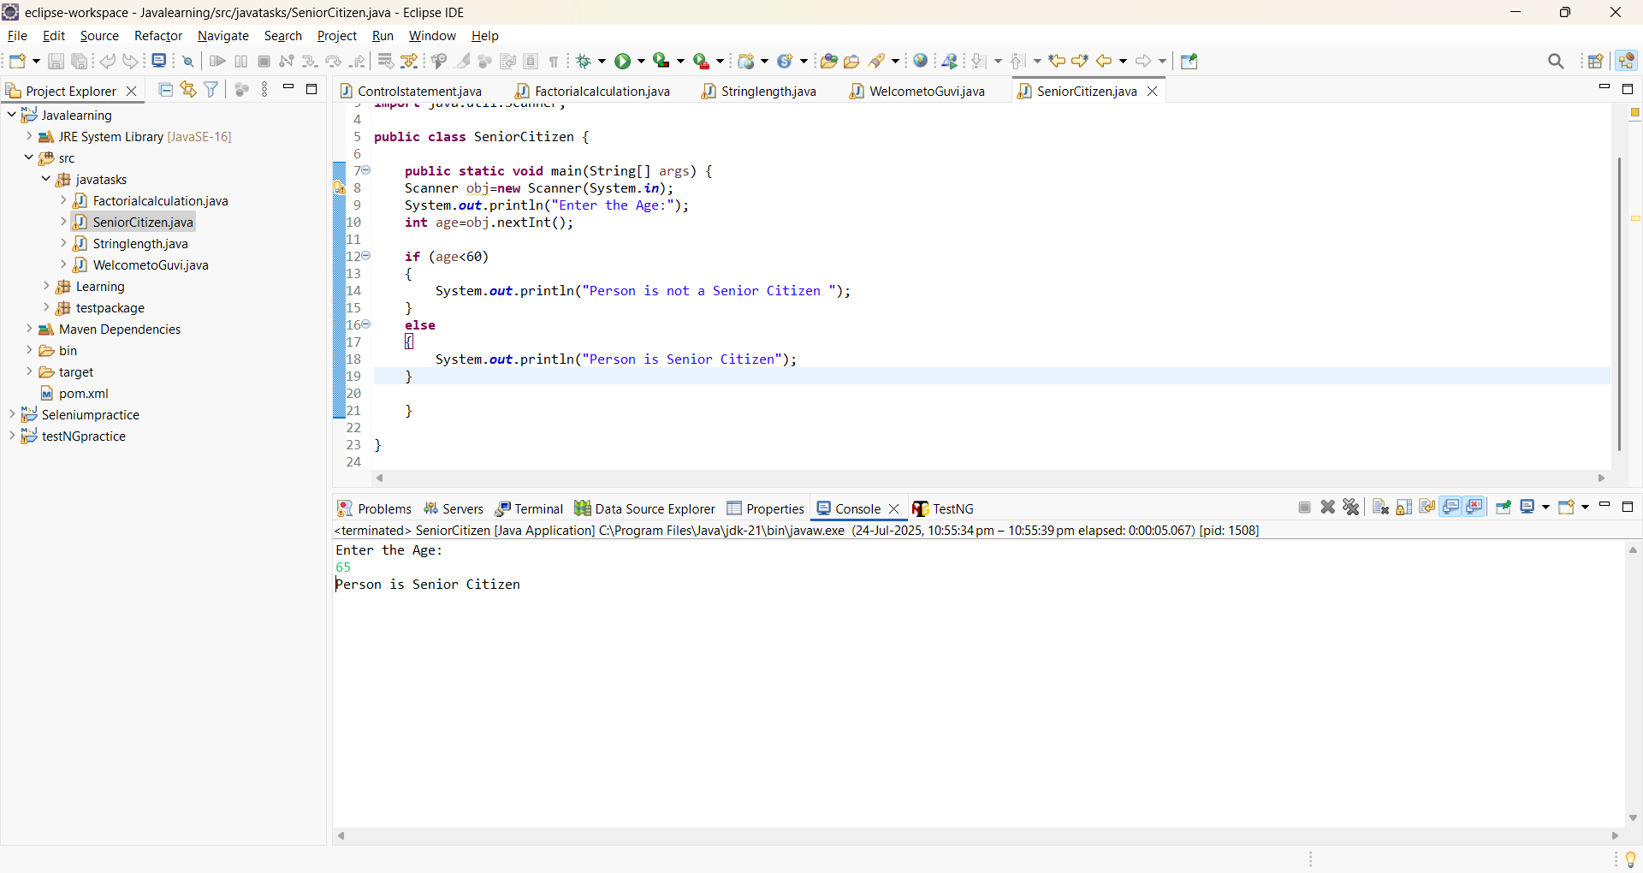

10 Program to count the number of digits in integer

